Quarch Technology Ltd

AN-017

Application Note

QPS automation with FIO

For use with:
XLC Power Modules
HD Power Modules
Quarch Power Studio (QPS)

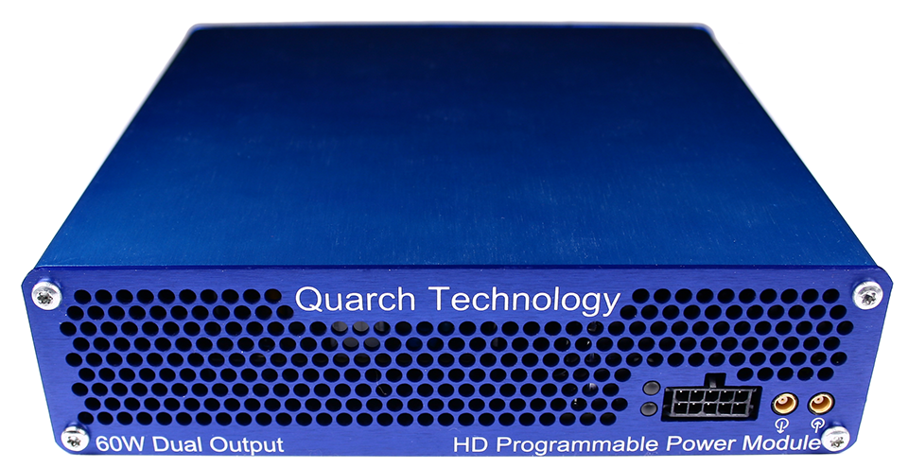

Change History
1.0 |  | Initial Release
1.1 | Feb 2019 | Updated to Python 3.x

Contents
Change History 2
Introduction 4
Modules Supported 5
System Supported 5
Application Note Example Files 5
Installation and setup 5
Python install 5
QuarchPy library install 6
Java install 8
QPS install 8
FIO install 8
Power module setup 9
Running the example 10

Introduction
Quarch Power Studio (QPS) is a unique system for recording and analyzing power consumption of storage devices. This application note demonstrates the ability to automate QPS and bring in user data from another source. In this example, FIO is used to drive traffic to a device and plot both power and performance as part of a fully automated test.

Modules Supported
XLC power modules
- QTL1824 (QTL1824-02A modules do NOT support streaming, but can be upgraded by Quarch)
- QTL1847
HD power modules
- QTL1995
- QTL1999

System Supported
This example is written and tested on Windows, though could be used on MacOS and Linux as long as FIO is installed.
It currently requires Python 2.x

Application Note Example Files
The AN-017.zip should be extracted to your preferred location.
scriptFIO.py | Main python file to execute
jobFileExample.fio | FIO Example configuration file

Installation and setup

Python install
If you do not already have Python installed, download and install it from:
https://www.python.org/downloads/
Under Windows it is helpful to make sure the Python installation directory and PythonXX\Scripts are included in the PATH environment variable. See:
https://docs.python.org/2/using/windows.html#excursus-setting-environment-variables

QuarchPy library install
The Quarch Python package can be installed from the Python web repository (assuming you have internet access) or via the download from our website.
Quarchpy will also install a version of Quarch Power Studio

Web Install
From the command line:
>pip install quarchpy
If this fails, your path to “pip” may not be set, you can instead run:
>python –m pip install quarchpy

Local Install
If you want to install from a downloaded folder, ensure the folder is unzipped to a local disk, navigate to the folder containing the setup.py file and run (noting the ‘.’ on the end):
>pip install quarchpy .
If this fails, your path to ‘pip’ may not be set, you can instead run:
>python –m pip install quarchpy .

Upgrade
If you already have QuarchPy installed, you will get a failure message. If you want to upgrade to a new version, you need to add the ‘--upgrade’ command:
>pip install --upgrade quarchpy
The --upgrade command can similarly be used in any of the other examples, to load from a local install folder.

Java install
Check that the Java JRE is installed
You can find install instructions and files here:
http://www.oracle.com/technetwork/java/javase/downloads/index.html

QPS install
Current versions of QPS are provided as a portable (non-install) .jar file
The latest version can be downloaded from here:
https://quarch.com/products/quarch-power-studio

FIO install
QuarchPy doesn’t ship with FIO. Follow the installation procedures described in https://github.com/axboe/fio according to your system and make sure the command fio is available in the system’s shell.
The readme.txt file on the main page lists “Binary Packages” which will be the starting point for most users who do not wish to compile themselves.

Power module setup
Connect the power module to the test PC and the output of the power module to the drive under test.

Customer Drive
USB/LAN Connection
Power Module
Customer Test PC

Running the example
QuarchPy ships with scriptFIO.py and supports two forms of integration with FIO:
- If you wish to use FIO without a file, you can populate the variable arguments with valid FIO arguments and the user will be prompted to select a target folder from a GUI window.
- For the users familiar with FIO configuration files, QuarchPy is able to import all settings from a .fio file.
The scriptFIO.py file demonstrates both options in sequence.
Before running this example, make sure you have a valid .fio file (as described in FIO’s manual) and its path is declared as the variable fioFile. You can use the jobFileExample.fio file provided with AN-017.
The variable arguments should be populated with valid FIO arguments (as described in FIO’s manual).

- You will be prompted to select the Quarch power module you want to connect to.
- If the power module’s outputs are disable, you will be prompted to enter a voltage mode (3V3 or 5V). If they are on from a previous run, the script will proceed.
- You will be prompted to enter an averaging rate. Pressing enter should use the default value of 32k.
- You will be prompted to select a target folder to run on, ensure that you select the correct drive (the one connected to Quarch’s power module), or the FIO test may erase important data!
- The script will now launch Power Studio, this may take a few seconds
- The script will iterate through every job described in the .fio file or the arguments variable.
- As each FIO run is executed, the script will:
  - Display the real time power consumption.
  - Annotate the start and end of each test.
  - Parse the FIO results and add the second-by-second performance data onto the chart.
